
ASSIGNMENT 5: DATABASE CREATION AND TABLE IMPLEMENTATION
DATABASE MANAGEMENT SYSTEM
ALLIANCE UNIVERSITY
Department of Computer Applications
SUBMITTED BY: RUPESH RL
REGISTER NO: 2511021240035
COURSE: BCA
YEAR: 2ND YEAR
PROJECT NAME: Courier and Parcel Delivery Management System

1. Aim
To create the database for the Courier and Parcel Delivery Management System and all its tables using SQL DDL commands, based on the final design from Assignment 3, with the primary keys and foreign keys defined properly.

2. Software Used
I used MySQL 8.0 and MySQL Workbench to run all the commands.

3. Finalized Design
In Assignment 3 I found that Parcel and Complaint were not in third normal form, so I made two changes. I added a new table Receiver and replaced the receiver columns of Parcel with ReceiverID. I also removed CustomerID from Complaint. The other tables are the same as in Assignment 2, so the final design has ten tables.
Table | Primary key | Foreign keys
Customer | CustomerID | -
Branch | BranchID | -
Employee | EmployeeID | BranchID → Branch(BranchID)
Vehicle | VehicleID | BranchID → Branch(BranchID)
Receiver | ReceiverID | -
Parcel | ParcelID | CustomerID → Customer(CustomerID); ReceiverID → Receiver(ReceiverID); BookingBranchID → Branch(BranchID); DestinationBranchID → Branch(BranchID)
Delivery_Assignment | AssignmentID | ParcelID → Parcel(ParcelID); EmployeeID → Employee(EmployeeID); VehicleID → Vehicle(VehicleID)
Parcel_Tracking | TrackingID | ParcelID → Parcel(ParcelID)
Payment | PaymentID | ParcelID → Parcel(ParcelID)
Complaint | ComplaintID | ParcelID → Parcel(ParcelID)

4. Creating the Database
First I create a database called courier_db and select it, so the tables are created inside it.
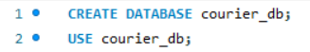

5. Creating the Tables
The order of creating the tables matters. A parent table (the one that is referred to) must be created before its child table (the one with the foreign key). If I create the child first, MySQL gives an error because the parent does not exist yet. So I created them in this order: Customer, Branch, Employee, Vehicle, Receiver, Parcel, Delivery_Assignment, Parcel_Tracking, Payment, Complaint.
In every table I used NOT NULL for the columns that must always have a value, PRIMARY KEY for the ID, and a named FOREIGN KEY for each link. For the foreign keys I used ON UPDATE CASCADE, so if a parent ID changes the child rows follow it, and ON DELETE RESTRICT, so a parent row cannot be deleted while child rows use it. Only Parcel_Tracking uses ON DELETE CASCADE, because tracking rows are of no use without their parcel. UNIQUE, CHECK and DEFAULT are added in the next assignment.

5.1 Customer
Stores the people who book parcels. No foreign key, so it is created first.
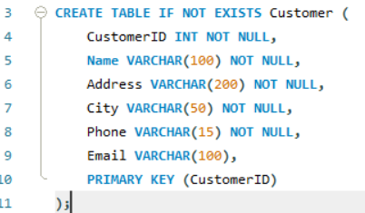

5.2 Branch
Stores the branch offices. No foreign key. Many other tables refer to it.
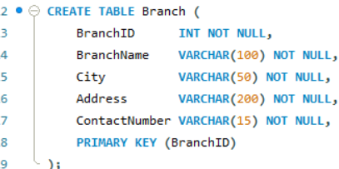

5.3 Employee
Stores the staff. BranchID links each employee to the branch where he or she works.
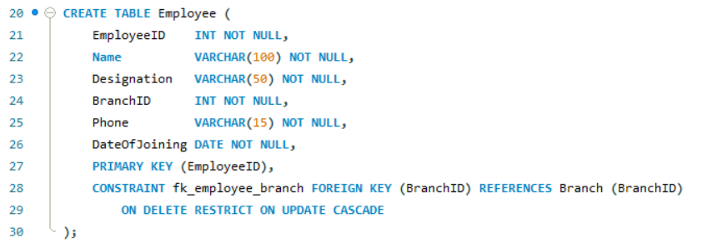

5.4 Vehicle
Stores the vehicles. BranchID links a vehicle to the branch where it is kept.
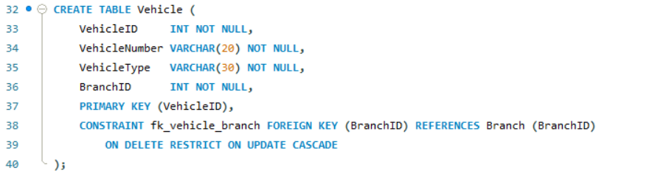

5.5 Receiver
Stores the people who receive parcels. This is the new table from Assignment 3, so that the receiver details are stored only once.
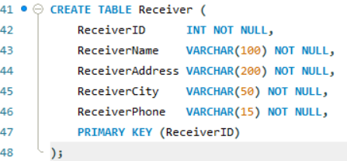

5.6 Parcel
The main table. It has four foreign keys: the customer who booked it, the receiver, the booking branch and the destination branch. The two branch columns both point to Branch.
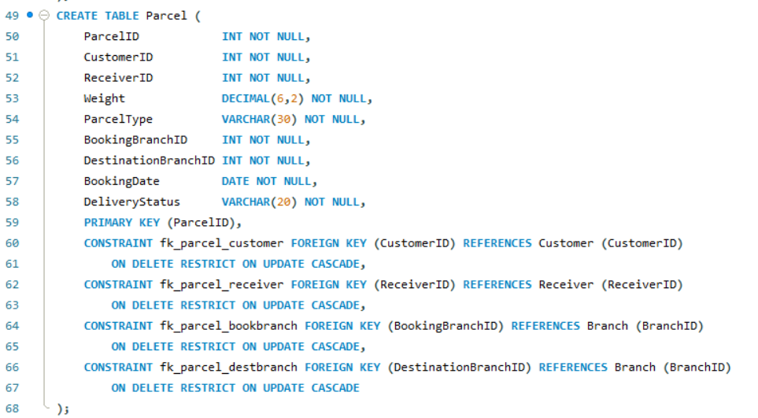

5.7 Delivery_Assignment
Links a parcel with the employee and the vehicle used for delivery. A parcel can have more than one row here if it is delivered again.
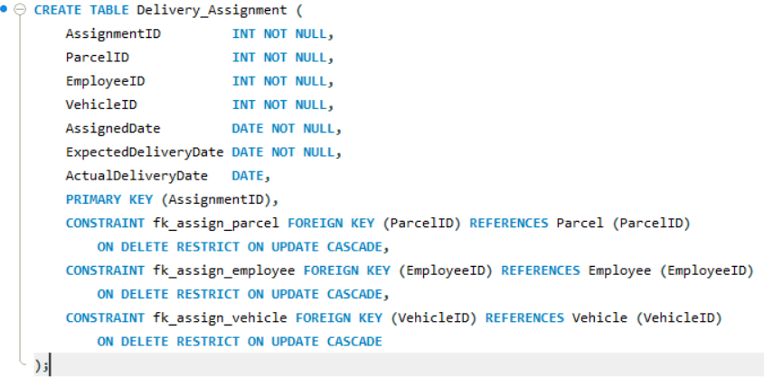

5.8 Parcel_Tracking
Stores the movement history of a parcel. ON DELETE CASCADE is used, so the history is removed with its parcel.
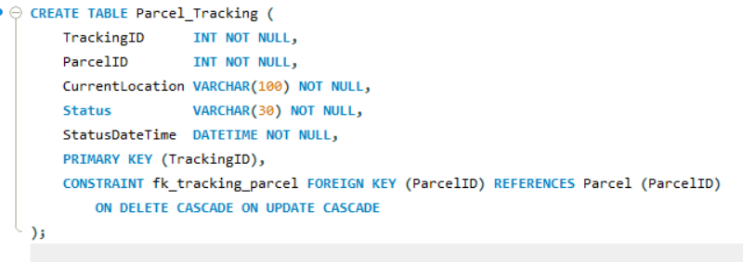

5.9 Payment
Stores the payment of a parcel. ParcelID is a foreign key to Parcel.
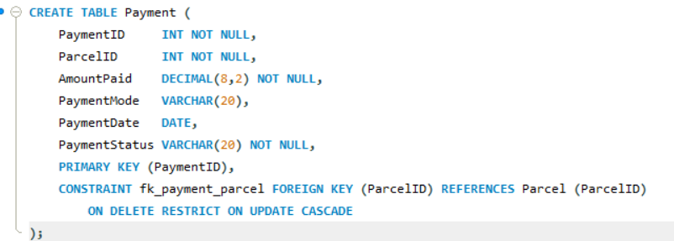

5.10 Complaint
Stores complaints about a parcel. The customer can be found through the parcel.
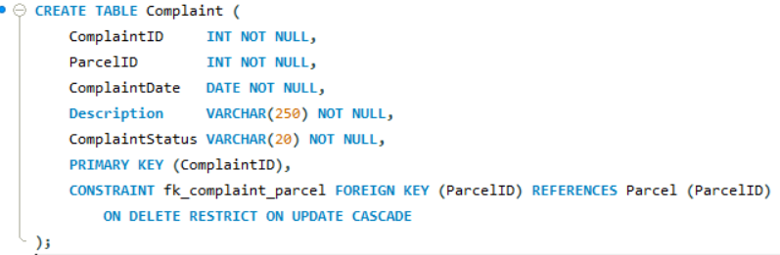

6. Verifying the Tables

6.1 Tables in the database
Output:
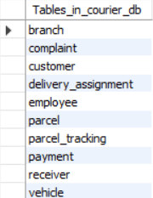
All ten tables are present.

6.2 Structure of each table
DESCRIBE shows the columns, data types, whether NULL is allowed and the key type. PRI means primary key and MUL means the column is a foreign key, so its value can repeat.
DESCRIBE Customer;
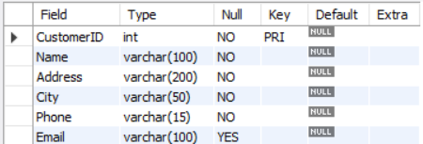

DESCRIBE Branch;
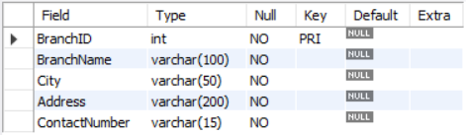

DESCRIBE Employee;
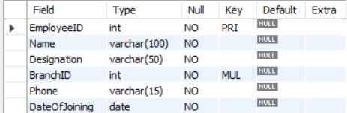

DESCRIBE Vehicle;
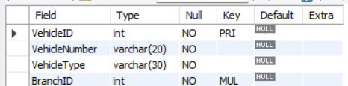

DESCRIBE Receiver;
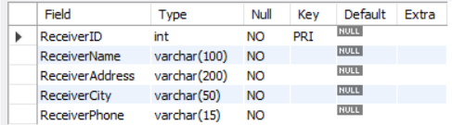

DESCRIBE Parcel;
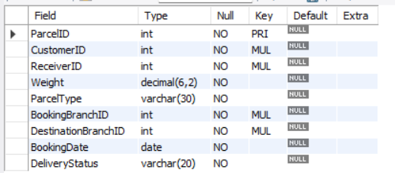

DESCRIBE Delivery_Assignment;
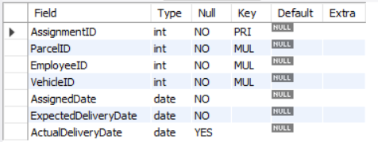

DESCRIBE Parcel_Tracking;
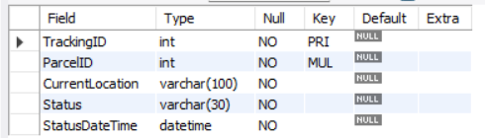

DESCRIBE Payment;
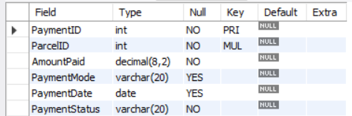

DESCRIBE Complaint;
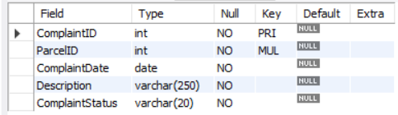

6.3 Foreign keys defined
This query reads the foreign keys from the information_schema of MySQL.
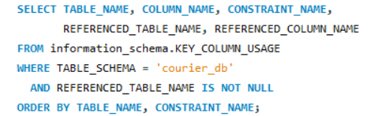
Output:
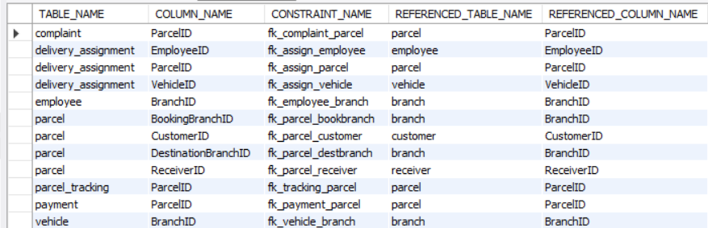
There are 12 foreign keys in total, and they match the relationships of the design.

7. Relationships Between the Tables
Relationship (parent → child) | Type | Foreign key column | Meaning
Branch → Employee | 1 : M | Employee.BranchID | One branch has many employees
Branch → Vehicle | 1 : M | Vehicle.BranchID | One branch keeps many vehicles
Customer → Parcel | 1 : M | Parcel.CustomerID | One customer books many parcels
Receiver → Parcel | 1 : M | Parcel.ReceiverID | One receiver can get many parcels
Branch → Parcel (booking) | 1 : M | Parcel.BookingBranchID | A branch is the booking branch of many parcels
Branch → Parcel (destination) | 1 : M | Parcel.DestinationBranchID | A branch is the destination of many parcels
Parcel → Delivery_Assignment | 1 : M | Delivery_Assignment.ParcelID | A parcel can have more than one assignment
Employee → Delivery_Assignment | 1 : M | Delivery_Assignment.EmployeeID | One employee handles many deliveries
Vehicle → Delivery_Assignment | 1 : M | Delivery_Assignment.VehicleID | One vehicle is used in many deliveries
Parcel → Parcel_Tracking | 1 : M | Parcel_Tracking.ParcelID | A parcel has many tracking updates
Parcel → Payment | 1 : 1 | Payment.ParcelID | One payment for each parcel (made one-to-one with UNIQUE in Assignment 6)
Parcel → Complaint | 1 : M | Complaint.ParcelID | A parcel can have many complaints

8. Result
The database courier_db was created with all ten tables. The DESCRIBE and information_schema outputs show the columns, the primary keys and the 12 foreign keys as planned.

9. Conclusion
Using DDL commands I created the database for the courier system as per my final design. Every table has a primary key, and the foreign keys link each child table to its parent, so the relationships of the design are now in the database. The remaining constraints are added in the next assignment.

